**Assignment no 10**

1)

2)

#include<iostream>

using namespace std;

#define pi 3.14

class overloading

{

public:

int area;

overloading(int x, int y)

{

area = x*y;

cout<<"area of rectangle is :"<<area;

}

overloading(int x)

{

area = x*x;

cout<<"\n area of square is :"<<area;

area = 3.14*x*x;

cout<<"\n area of circle is :"<<area;

}

};

int main()

{

overloading o(5,5);

overloading o1(4);

}

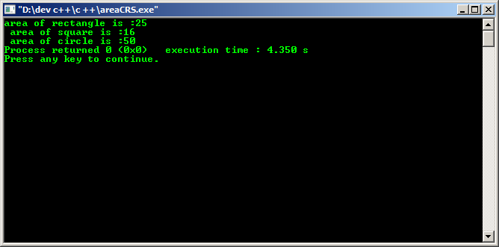

3)

#include <iostream>

using namespace std;

class overloading

{

public:

int pi,a,r;

void area()

{

cout<<"enter pi and r :"<<endl;

cin>>pi>>r;

a=pi*r*r;

cout<<"\n area of circle is :"<<a;

}

void area(int pi)

{

cout<<"enter r :"<<endl;

cin>>r;

a=pi*r*r;

cout<<"\n area of circle is :"<<a;

}

void area(int pi, int r)

{

a=pi*r*r;

cout<<"\n area of circle is :"<<a;

}

};

int main()

{

overloading o;

o.area();

o.area(5,3);

}